

Learn & Work Hub

**Course Title**

Entrepreneurial Thinking & Digital Models DSC

**Table of Content**

1. Executive Summary 3

2. Business Description & Vision 4

2.1. Mission 4

2.2. Vision 4

2.3. Strategic Plan 4

3. Industry 5

4. Market Analysis 6

4.1. Defining Customer 6

4.2. Direct and indirect competitors 7

4.3. Competitive Map 7

5. 5 forces of Porter 9

6. PESTEL 12

7. SWOT analysis: 13

8. Resources and Capabilities 14

9. Competitive Advantage 16

10. Marketing & Sales Strategy 17

10.1. Target Market 17

10.2. Marketing Strategy 18

10.3. Target Market Segmentation 18

10.3. Sales Strategy 20

10.4 Budget and Timeline 20

1. Operational Plan ....................................................................................................................................... 21
2. Management & Organization ............................................................................................................... 22
3. Financial Plan............................................................................................................................................ 23
4. Risk Analysis ............................................................................................................................................ 28

Conclusion ................................................................................................................................................................. 29

References .................................................................................................................................................................. 30

List of Table .............................................................................................................................................................. 35

List of Figures ........................................................................................................................................................... 36

Appendices ................................................................................................................................................................ 37

# 1. Executive Summary

Learn & Work Hub is a project focused on building a digital platform (web site) that combines freelancing opportunities with skill development and certification. It solves the disconnect between learning and job application by allowing freelancers to acquire, prove, and monetize skills in one space (Worklife, 2025). We will begin with the niche of data science. In this platform, you can learn about this course with video learning by yourself or with courses that help training companies without a platform offer their services to attend, and experienced users can upload their own courses. On this page you will share your portfolio of works, like Kaggle, and share own data set. This platform will help private companies, institutions, and normal people hire the services of login people who want to offer their services. The added value is that the first approach to the freelancer will be free to decide between the best options. Our personal support for new users and the bridge between the freelancer and companies in this niche, it will not too easy to copy this model to other companies. We will monetize the idea with a subscription for freelancers who want access to compete in any business and corporate offering, a free course to complete, private or public companies that need an analysis service, freemium users to access courses and access points to compete in a business offering, and courses offered online.

# 2. Business Description & Vision

## 2.1. Mission

Learn & Work Hub is the bridge between freelancers trained and certified with companies. We help people learn, prove, and earn from their skills by offering affordable, flexible courses, personal support, and a place to build and share their portfolio with potential clients around the world in data science.

## 2.2. Vision

Our vision is to empower a global workforce of data science professionals, enabling them to continuously learn, confidently demonstrate their abilities, and secure fulfilling work through our supportive community and innovative portfolio building tools rewarded with projects to work with the trust of companies.

## 2.3. Strategic Plan

Our strategic plan is center in differentiation and focus on the niche of data science. We will differentiate from other platforms by offering a niche in data science for freelancers, combining education, certification, and client access all in one place.

Figure 1. Logo.

Table 1. Strategic activities.

|  |  |
| --- | --- |
| **Goal** | **Description** |
| 1. Build a strong data science ecosystem *Learners* | Launch with 5+ high-quality courses. Average of 15 learners active in the platform. |
| 2. Establish Courses | Datasets, project and courses to receive learners. 35 by month |
| 3. Attract clients to hire talent *Freelancers* | Reach 15 (companies - private) by month and offer at least 1200 paid projects in Data science within the first year. We will offer 125 services by month. |

# 

# 3. Industry

Learn & Work Hub is in the industry of the Education Tech, and Freelance Marketplace industries, focus on Data Science and AI talent. This platform helps learners to upskill, certify, and monetize their expertise in a single ecosystem.

*Education Technology***.** Our idea belongs to this industry because the platform provides online learning, skill development, certification, with focus in the Data Science field. We have examples like Coursera (Coursera, 2025), Edx, (Edx, 2025), Udemy (Udemy, 2025)

*Freelance*. Like Upwork (Upwork, 2025), Fiverr (Fiverr, 2025) and Toptal (Toptal, 2025), that connect freelancers to clients.

*Data Science & AI Services Market (for the niche focus).* Initially focusing on data science freelancers and clients. We compete with platforms like Kaggle (Kaggle, 2025), DataCamp (Datacamp, 2025) in this niche. The Online Education market is projected to reach

US$203.81bn in 2025. Revenue is expected to show an annual growth rate (CAGR 20252029) of 8.20%, resulting in a projected market volume of US$279.30 bn by 2029. (Statista,

2025)

# 4. Market Analysis

In the world data science market size is estimated at USD 150.73 billion in 2024 and is anticipated to reach around USD 676.51 billion by 2034 (Precedenceresearch, 2025).

Freelancers in United States are 64 million and 47% are from IT services. It means there are a market of 30 million. And we are focus in the first year in 1.200 people that represent less than the 0.05% only related for initial inversion. In the future when we will growth as a company, we will increase our market (Moses, 2023).

#### 4.1. Defining Customer

*Aspiring Freelancers online.* Students or recent graduates People with basic skills in data science or tech who lack real experience. We offer to them learn in demand skills like data science, obtain certifications that are recognized, build a portfolio to prove competence, and they want to have their first freelance experience. In our platform structured courses online and offer a platform where they can upload their own portfolio, first free project analysis helps them get started with real work (CNN, 2025). Only in Coursera there are 168 million of people registered (Coursera, 2025) and by statistics only the 20% finish their courses (Learnstream, 2025).

*Experienced Freelancers online.* Freelancers want better payment or more consistent jobs. They have their own courses to provide. Expand services into new domains (e.g., from data analysis to AI modeling). Certifications and learning to prove skills. Public portfolios and ratings. Obtain money from their own courses offered (iab-forum, 2025).

*Companies, Startups, Individuals.* All Private Business, Public and NGOs, startups, and even non-technical clients from the world in website who need service for an idea or often don't know how to evaluate tech proposals related to data science.We will offer to hire skilled and certified freelancers for data-related projects, save time/money on trial and error, and get a first analysis for free to make better hiring decisions. Looking for portfolios and profiles free project analysis to test freelancer understanding. Quality assurance via certifications and platform for course (Entrepreuner, 2025).

#### 4.2. Direct and indirect competitors

*Direct Competitors.* All the companies that have similar features learn, job finding and freelancing. LinkedIn has learning and job finding in their core but in different platforms.

*Indirect Competitors*. Companies focus only in one feature of our company. Coursera, GitHub, Kaggle, Fiverr, Upwork.

#### 4.3. Competitive Map

As Learn & Work Hub is a platform who offers the blend and integration of freelancing, online learning and certificated skill development platforms targeting the data science community, the comparison will be focused in the following areas against our main competitors.

|  |  |  |  |  |  |
| --- | --- | --- | --- | --- | --- |
|  | L&W Hub | Udemy | Upwork | Kaggle | LinkedIn |
| Business Model | Integrated platform for both freelancing and learning | Learning platform, offers courses and certifications | Freelancing platform focused in various areas | Data  Science  Community platform for participating in | Professional Networking platform, job searching services, also works as a social network for |
|  | with focus on Data Science | of different areas |  | competitions , sharing their work, also offers courses. | professionals and recently added courses. |
| Freelancin g |  |  |  |  |  |
| Learning  & Skill Developm  ent |  |  |  |  |  |
| Certificati ons |  |  |  |  |  |
| Market | Data Science | Various areas. | Various areas. | Data  Science,  Machine  Learning, AI | Various Areas |
| Pricing model | Freemiumpremium subscriptionbased service, rewards system | Mix model: Sells courses and subscriptionbased service | Subscription based service | Mostly free services | Subscription based services |
| Unique Features/A dded Values | Integrate service, data science focus, rewards system, price model | Market reach, lifetime payment subscription, discounts, and affordable pricing.  Marketplace business model | Leaders in the market. Great quality filters for freelancers, rigorous processes to get in.  Multiple incomes, freelancers' subscription s, premium services for clients, enterprise focus. | Most famous site for Data Science community,  community driven business model, constant updates, free access to cloud Data Bases micro. Courses for data science community | Worldwide leading platform, focus on personal and company  clients, job search, courses, content sharing and paper publishing. |

### 5. 5 forces of Porter

This project addresses the traditional gap between learning new skills and applying them directly in the workforce. To better understand its strategic positioning and potential challenges, the business idea is analyzed using Michael Porter’s Five Forces Model (GRATTON, P, 2025).

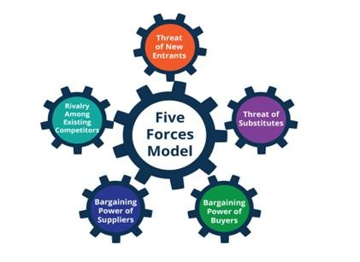

Figure 2. 5 Forces Porter

*Rivalry Among Existing competitors.* There are outnumbers of platform, who deliver the online skill-based education and freelancing for more than decade such as Udemy, Coursera, Upwork, Fiverr and the organization like Google, Microsoft and IBM are launching free online education which makes this market populated makes more difficult to enter in this red ocean (Coursera, 2025; Fiver, 2023; Udemy, 2025; Upwork, 2024).

However, Learn & Work Hub’s unique proposition of integrating learning, certification, portfolio building, and freelancing opportunities creates a differentiated and gives an upper hand in the market. Despite this, rivalry remains intense as established players can quickly imitate features. Building a strong, loyal user base and offering verified certifications can provide Learn & Work Hub with a sustainable competitive advantage.

*Threat of New Entrants.* The threat of new entrants is high, although developing a platform that blends freelancing, education, and credentialing requires significant investment in technology, course creation, and community building. Competitors with established brand names could easily enter if the business model proves beneficial. Therefore, early market penetration and brand positioning are crucial to establishing as the leader in this market

(HARVARD BUSINESS SCHOOL, 1979).

*Threat of Substitute.* There are many platforms and users are independent to choose.

Platforms like Udemy for gaining skills and linked in for the portfolio development, Upwork for the freelancing and some of the organization still prefer traditional way to hire a people, which makes threat level moderate to high. To minimize the threat of substitutes, Learn & Work Hub must focus on creating a unique and seamless user experience that unifies learning, certification, offering verified certifications, personalized learning trajectories, quality freelancing work, and reputation systems based on community could go a long way in lowering users' intent to switch to substitute solutions.

*Bargaining Power of Buyer*. Buyer bargaining power on the Learn & Work Hub is extremely high and needs to be negotiated thoroughly in order to be effective in the long run. The two major user groups are freelancers and companies.

For companies, their bargaining power is high because they have plenty of options. If freelancers on the Learn & Work Hub cannot meet their needs in terms of skills, price, or quality, they can easily jump to other platforms.

Freelancers have less control when there are more of them than projects. If the platform is not giving them projects or access to resources in regular intervals so that they can grow, they may switch to other platforms that better meet their professional opportunities

*Bargaining Power of Suppliers*. In Learn & Work Hub, suppliers refer to the individuals and organizations that provide the platform’s educational content, training services, certification programs. Their bargaining power is moderate. At the beginning, Learn & Work Hub heavily depends on experienced course creators, training companies, and industry experts to increase the platform with high-quality learning materials and certifications. Therefore, suppliers who have strong reputations and have specialized knowledge could hold significant bargaining power, demanding higher fees, better revenue-sharing models, or special placement on the platform.

Learn & work Hub strategically reduce supplier bargaining power over time by allowing user-generated content, just as platforms like YouTube and Udemy, it can empower its community to contribute, thereby maintaining a rich content ecosystem without overrelying on a few powerful suppliers (CIPS, 2023).

### 6. PESTEL

*Political :*

Digital learning is being promoted by numerous governments, which is encouraging. However, things like new freelance tax laws may have an impact on how we operate. We will attempt to keep you informed and make any necessary adjustments.

*Economical :*

People are learning skills on the side as the gig economy expands. However, inflation

indicates that some people cannot afford to take paid courses. Therefore, we're considering flexible pricing or even sponsored options that are free.

*Social :*

Nowadays, people prefer to learn on their own schedule, particularly since remote work is becoming more and more common typical. Our goal is to make our content relatable so that users can learn on their own speed. Stories and real-world examples will help with that.

*Technological :*

Technology is evolving quickly, particularly with AI tools now being used everywhere.

To keep the platform current and useful, we will need to make regular improvements (World Economic Forum, 2023).

*Ecological :*

Because it uses less paper and travel, online education already benefits the environment.

Nevertheless, we intend to minimize digital waste and use eco-friendly hosting.

*Lawful :*

We must exercise caution when it comes to data regulations like GDPR. We'll follow the guidelines and periodically review everything to prevent issues.

### 7. SWOT analysis:

|  |  |
| --- | --- |
| Strengths: | Weaknesses: |
| It is a digital platform, with a unique 3-in1 format, freelancing, training (portfolio) and certification. | Limited budget to attract the first users, (development and operation of the platform costs a lot of money, cybersecurity costs, server maintenance, staff salaries and marketing). |
| Low commission model (less than 20%) offers freelancers more favorable conditions compared to Fiverr and Upwork. | It is a new brand, (lack of trust of users and companies). |
| Unified ecosystem (unique information systems protected by big data analytics, artificial intelligence-based matching and user-friendly). | There could be quality control issues, especially if they allow creating courses and portfolios for users (like Udemy). |
| Fast transition from learning to practice and high income (a combination of training, pumping skills to meet market requirements, certification and freelancing on a single platform dedicated to Data Science). | The business model is complex. It combines freelancing and education. It can confuse people if not explained properly. Users expect maximum convenience and simplicity. |

|  |  |
| --- | --- |
| Opportunities | Threats |
| The freelancing and remote work economy is growing rapidly. More and more companies and people around the world are looking for flexible contracts for specific projects. | Competition from well-known sites such as Fiverr, Upwork, LinkedIn, Kaggle, Udemy and Coursera. They are vying for people's attention and for the opportunity to make lucrative offers. |
| There is an increasing demand for data science and AI skills, and the investment of companies in this industry(Sachs,2025). It's a growing field, with good salary potential and a shortage of skilled workers. (see Appendix A) | Competitors are quick to copy unique features. Big players like Upwork, Fiverr or LinkedIn can easily copy the combined Learn & Work Hub model if it becomes successful. |
|  |  |
| Expansion into international markets. There is a growing trend toward microcertifications and skill badges. Employers value certificates that focus on specific skills more than traditional diplomas. | Regulatory changes. New gig economy laws (e.g. California's AB5 (Kerr, 2024) and EU freelancer laws (European Parliament, 2019)) could increase operating costs or require freelancers to be classified differently. |
| The use of Data Science will lead to the expansion of other fields such as web development, cybersecurity, artificial intelligence, and marketing analytics. | Artificial intelligence tools may automate some freelancer tasks (especially in data analytics), which will reduce the demand for freelancers in some industries. |

### 8. Resources and Capabilities

Growing demand for online education and freelancing, entering international markets, popularization of “an IT specialist in every family” approach, this is the competitive strength of Learn & Work Hub. Our platform has a unique 3-in-1 format combining online learning, skills certification and freelancing opportunities, particularly in the field of data science. We use Resource-Based View (RBV) to evaluate our core assets on four dimensions: Value, Rarity, Inimitability/ Non substitutable, and Durability (Barney, 1991).

*Valuable.* The platform adds value by allowing users to learn, earn certificates, and earn money in one place. This eliminates the inefficiencies of multiple platforms such as Udemy, Coursera, and Upwork (Coursera, 2025; Upwork, 2024). Our methodology helps users create new career models, and companies easily acquire vetted, ready-to-go freelancers.

*Rare.* Our focus on data science and artificial intelligence is what sets us apart from our competitors. It is noteworthy that few platforms specialize in this area and offer full integration of learning with earnings. This degree of proficiency is seldom observed within the broader EdTech and freelance sectors (Datacamp, 2025; Kaggle, 2025).

*Inimitable/Non substitutable.* It is challenging to replicate the platform's features, including its rewards system, portfolio sharing, certification, and AI-powered matching technology. Most competitors offer only a fraction of this concept, forcing users to seek alternative platforms (Fiverr, 2023; LinkedIn, 2025).

*Durable.* The concept of first-member advantage, the use of user reputation systems such as verified badges and reviews, and the implementation of personalized support have been shown to increase user retention and reduce the risk of impersonation. Value increases in proportion to the number of freelancers and clients who join, thus reinforcing network effects (LinkedIn, 2025; Statista, 2024).

Ability to scale the platform to other languages and countries.

Table 2. VRIN Summary Table.

|  |  |  |  |  |
| --- | --- | --- | --- | --- |
| Resource/Capabilit y | Valuable | Rare | Inimitable/Non -Substitutable | Durable |
| Integrated platform  (learning + freelancing) |  |  |  |  |
| Data science niche focus |  |  |  |  |
| Certification + project validation |  |  |  |  |
| AI-powered matching system |  |  |  |  |
| Remote, skilled workforce |  |  |  |  |
| Strategic partnerships (B2B + training) |  |  |  |  |
| Freemium + subscription business model |  |  |  |  |

### 9. Competitive Advantage

Learn & Work Hub is a unique platform that combines training, certification and freelancing. Learn & Work Hub is different because it offers a complete set of services. This full cycle allows you to go from education to work. The use of new technology and methodology focused on specific fields and user experience is a competitive advantage.

One of the best features of Learn & Work Hub is its focus on data science and artificial intelligence. While other platforms cover a multitude of topics, Learn & Work Hub offers specialized training and the ability to complete individualized projects in rapidly evolving fields. This special method allows the program to offer more value by matching skill development to specific job requirements (Datacamp, 2025; Kaggle, 2025).

The platform uses a hybrid monetization strategy, combining different business models. It is similar to the monetization strategy used by Fiverr Business and Coursera Plus. And it offers a freemium model with free courses and job listings, as well as premium subscriptions, course sales, portfolio promotion, and low commissions on freelancer contracts. This makes freelancers more likely to stay on the platform (Coursera, 2025; Fiverr, 2023).

Using advanced technology such as artificial intelligence to connect freelancers with suitable projects, advanced data analytics for personalized learning paths, and automated secure payments. These systems have been shown to enhance user experience and facilitate growth while maintaining reliability and trust (Coursera, 2025; Upwork, 2024). Trust is also enhanced by reputation tools such as verified badges and public portfolios (Fiverr, 2023). These entities facilitate comprehension among their clientele regarding the qualifications of freelance professionals. The provision of a complimentary analysis of the initial project serves to mitigate risk for clients.

The Learn & Work Hub has been designed to allow for facile scaling up or down. By owning every step of the journey from learning to earning, it capitalizes on network effects and economies of scale. As the number of learners and businesses that utilize the platform increases, its value is enhanced, leading to a reduction in customer attrition and a strengthening of its market position (LinkedIn, 2025).

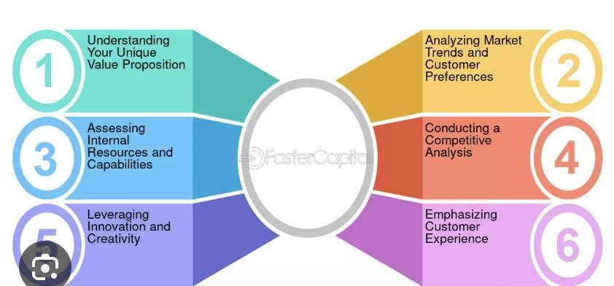

Figure 3. Identifying Competitive Advantages

# 10. Marketing & Sales Strategy

## 10.1. Target Market

Our primary audience includes aspiring freelancers and students (ages 18–50) who are seeking skill development in data science, as well as companies and organizations looking to hire certified freelance professionals. Secondary audiences include experienced freelancers interested in expanding their services and clients in non-technical fields needing data-driven support.

#### 10.2. Marketing Strategy

We will adopt a multi-channel marketing approach to effectively reach our target audience. Social media campaigns on platforms like Instagram, LinkedIn, and YouTube will help us engage with freelancers and students (Neil Patel, 2023). Content marketing will play a key role, with regular blog posts, tutorials, and webinars designed to improve our SEO and build brand visibility. Paid advertising through Google Ads and LinkedIn Ads will focus on keywords related to education and data science to attract both learners and clients (McKinsey, 2023). To encourage organic growth, we will implement referral programs that reward users for bringing new members to the platform. Additionally, strategic partnerships with universities, tech bootcamps, and coworking spaces will help us expand our reach and establish credibility within the data science and education ecosystem(Steve Blank, 2023; Pearson, 2023).

#### 10.3. Target Market Segmentation

The primary target market for this platform includes aspiring data science freelancers aged 18 to 35. This group mainly consists of students and recent graduates seeking their first freelance opportunities, as well as career changers who need projects to build their portfolios. Additionally, certified professionals who create and upload courses form a crucial part of the audience, benefiting from a revenue-sharing model where 70% goes to the creator and 30% to the platform. Alongside freelancers, the platform also focuses on small-to-medium businesses such as startups and companies without in-house data teams that require affordable data analysis services. Secondary audiences include enterprise clients like large corporations looking for reliable freelance pipelines, educational partners such as universities and coding bootcamps, and service providers including career coaches and recruiters who can support the platform’s ecosystem.

*Multi-Channel Marketing Strategy.* To reach these audiences effectively, a multi-channel marketing strategy will be implemented. This includes paid digital advertising such as LinkedIn ads targeting users interested in data science careers, and Google search ads using keywords like “hire data freelancers” and “learn data science.” Organic growth efforts will focus on maintaining an SEO-optimized blog with two weekly posts and a YouTube tutorial series titled “From Learning to Earning.” Community engagement will be fostered through a LinkedIn group for certified freelancers and monthly “Data Challenge” competitions that encourage skill-building and networking (Steve Blank, 2023).

*Promotional Tactics.* During the launch phase (months one through three), incentives will be offered such as a free certification badge to the first 500 freelancers who sign up, a 20% discount for clients posting their first project, and a spotlight feature for course creators to increase their visibility(Pearson, 2023). Ongoing programs will include “Top Performer” rewards that boost platform visibility for high-achieving freelancers and seasonal skill sprints offering bonuses upon completion to keep users motivated and engaged.

*Strategic Partnerships.* Strategic partnerships will play a key role in growth. (Deloitte, 2023) Collaborations with education partners will involve revenue-sharing agreements with coding bootcamps and offering white-label solutions to universities. Corporate partnerships will focus on securing preferred vendor status with tech recruiters and organizing co-branded workshops with coworking spaces to increase brand presence.

#### 10.3. Sales Strategy

Table 3.Sales Strategy

|  |  |  |  |  |
| --- | --- | --- | --- | --- |
| **Revenue** | **Who Pays** | Price | Profit | Observations |
| **1. Freelancer**  **Fremium** | Freelancers | 0 | 0 | Participate in challenges to apply in jobs (Advertising 100 EUROS by companies) |
| **2. Freelancer Pro** | Freelancers | 20 | 20 | Pro: Apply to more jobs, profile insights |
| **3. Freelancer Elite** | Freelancers | 30 | 30 | Elite: Certification badge, premium visibility |
| **4. Client**  **Subscription by job** | Clients / Companies | 1200 | 200 | By job |
| **5. Client**  **Subscription Plans Pro** | Clients / Companies | 1000 | 60 | Pro: Full access to verified companies |
| **6. Client**  **Subscription Plans Enterprise** | Clients / Companies | 800 | 120 | Enterprise: Priority support, team collaboration tools |
| **7. Online Course**  **Sales** | Teachers | 60 | 30 | Courses by experts or platform partners upload; 70/30 revenue split |
| **8. Certification**  **Couse Fees** | Learners | 50 | 15 | Includes skill assessments and verified badge 70/30 |
| **9. Certification Couse Fees Premium** | Learners | 40 | 20 | Includes skill assessments and verified badge premium |

#### 10.4 Budget and Timeline

Initial monthly budget $2,000 for ads (Google, LinkedIn) $500 for content creation and SEO tools.

*Timeline*. Month 1: Launch social media campaigns and referral system. Month 2: Evaluate ad performance, optimize keywords, scale content. Month 4–6: Introduce new premium plans and targeted sales emails

##### Operational Plan

Learn & Work Hub will function as a hybrid online platform that provides chances for study as well as freelance work. The business will first concentrate on creating a solid MVP (Minimum Viable Product) that incorporates project matching algorithms, learning modules, certification administration, and safe payment mechanisms.

The team will be made up of remote workers in marketing, customer service, development, and content positions. Every effort will be made to automate freelancer matching, course publication, and customer onboarding. Data analytics will be heavily emphasized in order to enhance user retention and customize learning pathways.

In order to guarantee a dual flow of people and projects, operational focus will also involve establishing alliances with corporate clients and bootcamps.

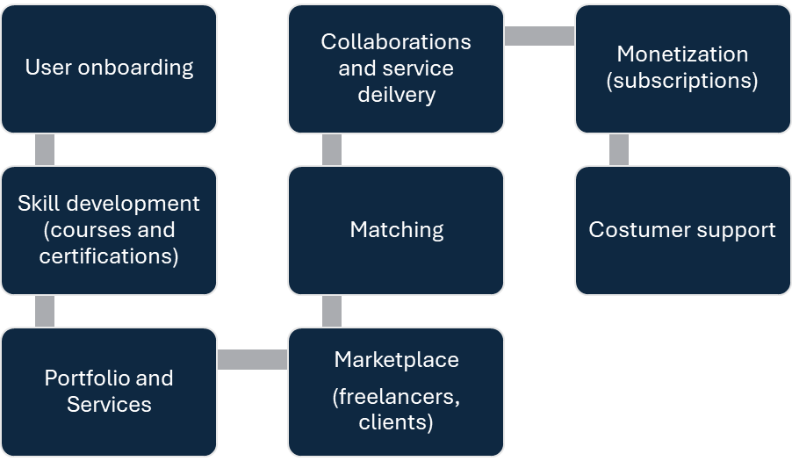

Figure 4. Operational Plan

##### Management & Organization

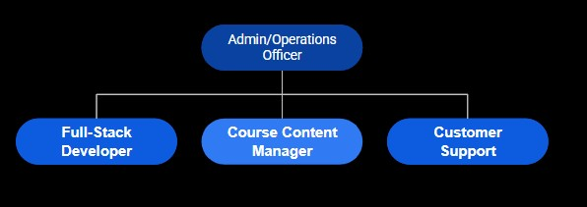

Figure 5. Organization.

**Course Content Manage** Role description

1. Admin/ Operations officer.
   1. Direction, strategies, and project development.
   2. Stake holders relationships and investors adquisition (Technext, 2024).
   3. Legal, payment, CRM tools, basic HHRR management
2. Full Stack Web Developer
   1. Web site development and maintenance front end and back end

(Functionly, 2025)

1. Course Content Manager
   1. Online courses development and freelancers management.
   2. Academic development and Maintenance, certifications (Technext, 2024).
2. Customer & Support Lead
   1. Customer service and support for users y freelancers.
   2. Community development, bridge between freelancers and companies

(Functionly, 2025)

##### Financial Plan

The financial plan for Learn & Work Hub focuses on creating multiple scalable online revenue that support a sustainable and growth digital platform and this analysis we made by a period of a year and a forecast of 4 years.

*Initial Inversion***.** At the beginning of the business, we need in total 20.000 Euros the following inversion.

Table 4. Initial Inversion.

|  |  |  |
| --- | --- | --- |
| **Item** | **Purpose** | **One-Time Cost** |
| **1. Platform Development**  **(MVP)** | Website/app core build, login, LMS, portfolio system | € 12,000 |
| **2. Branding & Design** | Logo, UI kit, basic brand assets | € 1,000 |
| **3. Course Content**  **(Initial)** | Pay instructors or license 5–10 courses | € 2,500 |
| **4. Legal & Company**  **Setup** | Legal fees, business registration, contracts | € 1,500 |
| **5. Marketing Launch**  **Budget** | Launch campaign: email, SEO, social, influencers | € 2,000 |
| **6. Misc. Tools & Setup** | CRM, task management, domains, licenses | € 1,000 |
|  | **TOTAL** | **€ 20,000** |

*Income***.** The income we define with the price of the service and an amount of customer increasing along the months.

Table 5. Sales by month.

###### Who Pays JAN FEB MAR APR MAY JUN JUL AUG SEP OCT NOV DEC TOTAL

|  |  |  |  |  |  |  |  |  |  |  |  |  |  |
| --- | --- | --- | --- | --- | --- | --- | --- | --- | --- | --- | --- | --- | --- |
|  |  |  |  |  |  |  |  |  |  |  |  |  |  |
| Freelancers | € 500 | € 500 | € 500 | € 500 | € 500 | € 500 | € 500 | € 500 | € 500 | € 500 | € 500 | € 500 | € 6,000 |
| Freelancers | € 40 | € 120 | € 300 | € 400 | € 680 | € 680 | € 720 | € 800 | € 1,000 | € 1,080 | € 1,240 | € 1,320 | € 8,380 |
| Freelancers | € 90 | € 270 | € 360 | € 900 | € 1,530 | € 1,530 | € 1,620 | € 1,800 | € 2,250 | € 2,430 | € 2,700 | € 2,700 | € 18,180 |
| Clients /  Companies | € 400 | € 400 | € 1,200 | € 4,000 | € 6,000 | € 6,000 | € 7,000 | € 7,000 | € 7,000 | € 7,000 | € 7,000 | € 7,000 | € 60,000 |
| Clients /  Companies | € 50 | € 150 | € 150 | € 700 | € 700 | € 700 | € 750 | € 850 | € 950 | € 1,050 | € 1,150 | € 1,250 | € 8,450 |
| Clients /  Companies | € - | € - | € 100 | € 20 | € 300 | € 300 | € 300 | € 300 | € 600 | € 600 | € 800 | € 800 | € 4,120 |
| Teachers | € 90 | € 90 | € 300 | € 600 | € 600 | € 600 | € 1,800 | € 1,800 | € 1,800 | € 1,800 | € 1,800 | € 1,800 | € 13,080 |
| Learners | € 15 | € 15 | € 60 | € 750 | € 750 | € 750 | € 825 | € 2,475 | € 2,475 | € 7,425 | € 7,425 | € 7,425 | € 30,390 |
| Learners | € 20 | € 20 | € 200 | € 4,000 | € 4,000 | € 4,000 | € 4,000 | € 4,000 | € 4,000 | € 4,000 | € 4,000 | € 4,000 | € 36,240 |
|  | **€ 1,205** | **€ 1,565** | **€ 3,170** | **€ 11,870** | **€ 15,060** | **€ 15,060** | **€ 17,515** | **€ 19,525** | **€ 20,575** | **€ 25,885** | **€ 26,615** | **€ 26,795** | **€ 184,840** |

Our service for companies that needs a service to hire from a freelancer is the most profitable compared with the others. At the beginning of the business, we are going to star with few customers but increase along the months.

Table 6. Amount of customer.

**Who Pays JAN FEB MAR APR MAY JUN JUL AUG SEP OCT NOV DEC**

|  |  |  |  |  |  |  |  |  |  |  |  |  |
| --- | --- | --- | --- | --- | --- | --- | --- | --- | --- | --- | --- | --- |
|  |  |  |  |  |  |  |  |  |  |  |  |  |
| Freelancers | 5 | 5 | 10 | 30 | 90 | 270 | 500 | 500 | 500 | 500 | 500 | 500 |
| Freelancers | 2 | 6 | 15 | 20 | 34 | 34 | 36 | 40 | 50 | 54 | 62 | 66 |
| Freelancers | 3 | 9 | 12 | 30 | 51 | 51 | 54 | 60 | 75 | 81 | 90 | 90 |
| Clients /  Companies | 2 | 2 | 6 | 20 | 30 | 30 | 35 | 35 | 35 | 35 | 35 | 35 |
| Clients /  Companies | 1 | 3 | 3 | 14 | 14 | 14 | 15 | 17 | 19 | 21 | 23 | 25 |
| Clients /  Companies | 0 | 0 | 1 | 3 | 3 | 3 | 3 | 3 | 6 | 6 | 8 | 8 |
| Teachers | 3 | 3 | 10 | 20 | 20 | 20 | 60 | 60 | 60 | 60 | 60 | 60 |
| Learners | 1 | 1 | 4 | 50 | 50 | 50 | 55 | 165 | 165 | 495 | 495 | 495 |
| Learners | 1 | 1 | 10 | 200 | 200 | 200 | 200 | 200 | 200 | 200 | 200 | 200 |

**Disbursement.** In our business we will have along the first month an increasing of the expenses, that is related with the low income but we try to have the positive cash flow.

Table 7. Disbursement.

**Category Description Monthly Cost JAN FEB MAR APR MAY JUN JUL AUG SEP OCT NOV DEC TOTAL**

|  |  |  |  |  |  |  |  |  |  |  |  |  |  |  |  |
| --- | --- | --- | --- | --- | --- | --- | --- | --- | --- | --- | --- | --- | --- | --- | --- |
| **1. Web Hosting & Cloud Services** | AWS, Azure, or similar (storage, compute, database) | € 300 | € 300 | € 300 | € 300 | € 300 | € 1,000 | € 1,000 | € 1,000 | € 3,000 | € 3,000 | € 4,000 | € 4,000 | € 4,000 | € 22,200 |
|
| **2. Marketing & Ads** | Online ads (LinkedIn, Meta, Google) | € 800 |  |  |  | € 800 | € 800 | € 800 | € 800 | € 1,000 | € 1,500 | € 2,000 | € 2,000 | € 2,000 | € 11,700 |
| **3. Admin & Operations** | Legal, accounting, admin tools (e.g., Notion, email) | € 300 | € 300 | € 300 | € 300 | € 300 | € 300 | € 300 | € 300 | € 500 | € 1,000 | € 1,000 | € 1,000 | € 1,000 | € 6,600 |
| **4. Payment Processing Fees** | Stripe, PayPal, etc. (~2.5% of revenue) | € 265 | € 265 | € 265 | € 265 | € 265 | € 500 | € 500 | € 500 | € 500 | € 500 | € 500 | € 500 | € 500 | € 5,060 |
| **5. Full-Stack Developer** | Build and maintain the platform (frontend + backend) | € 5,500 |  |  |  | € 5,500 | € 5,500 | € 5,500 | € 5,500 | € 5,500 | € 5,500 | € 5,500 | € 5,500 | € 5,500 | € 49,500 |
| **6. Course Content Manager** | Manage course uploads, quality control, instructor onboarding | € 3,000 |  |  |  |  |  |  | € 3,000 | € 3,000 | € 3,000 | € 3,000 | € 3,000 | € 3,000 | € 18,000 |
| **7. Customer Support (1 people)** | Respond to freelancer/client inquiries, onboarding support (shift coverage) | € 1,500 |  |  | € 1,500 | € 1,500 | € 1,500 | € 1,500 | € 1,500 | € 1,500 | € 1,500 | € 1,500 | € 1,500 | € 1,500 | € 15,000 |
| **9. Admin / Operations Officer** | Handle legal, payments, partnerships, CRM tools, basic HR | € 3,000 |  |  |  | € 3,000 | € 3,000 | € 3,000 | € 3,000 | € 3,000 | € 3,000 | € 3,000 | € 3,000 | € 3,000 | € 27,000 |
| **10.Office** | Rent office | € 1,500 |  |  |  |  | € 1,500 | € 1,500 | € 1,500 | € 1,500 | € 1,500 | € 1,500 | € 1,500 | € 1,500 | € 12,000 |
|  | **TOTAL** | **€ 16,165** | **€ 865** | **€ 865** | **€ 2,365** | **€ 11,665** | **€ 14,100** | **€ 14,100** | **€ 17,100** | **€ 19,500** | **€ 20,500** | **€ 22,000** | **€ 22,000** | **€ 22,000** | **€ 167,060** |

***Cash Flow*.** In the initial cash flow says that the lowest point is January with 340 Euros, we don’t have in any month a cash flow negative.

Table 8. Cash Flow

|  |  |  |  |  |  |  |  |  |  |  |  |  |  |
| --- | --- | --- | --- | --- | --- | --- | --- | --- | --- | --- | --- | --- | --- |
| **INITIAL FLOW CASH** | **JAN** | **FEB** | **MAR** | **APR** | **MAY** | **JUN** | **JUL** | **AUG** | **SEP** | **OCT** | **NOV** | **DEC** | **TOTAL** |
| Receipts | € 1,205 | € 1,565 | € 3,170 | € 11,870 | € 15,060 | € 15,060 | € 17,515 | € 19,525 | € 20,575 | € 25,885 | € 26,615 | € 26,795 | € 184,840 |
| Disbursements | € 865 | € 865 | € 2,365 | € 11,665 | € 14,100 | € 14,100 | € 17,100 | € 19,500 | € 20,500 | € 22,000 | € 22,000 | € 22,000 | € 167,060 |
| Beginning Balance |  | € 340 | € 1,040 | € 1,845 | € 2,050 | € 3,010 | € 3,970 | € 4,385 | € 4,410 | € 4,485 | € 8,370 | € 12,985 | € - |
| Equity Investment | € - | € - | € - | € - | € - | € - | € - | € - | € - | € - | € - | € - | € - |
| Net Cash Flow | € 340 | € 700 | € 805 | € 205 | € 960 | € 960 | € 415 | € 25 | € 75 | € 3,885 | € 4,615 | € 4,795 | € 17,780 |
| Ending Balance | € 340 | € 1,040 | € 1,845 | € 2,050 | € 3,010 | € 3,970 | € 4,385 | € 4,410 | € 4,485 | € 8,370 | € 12,985 | € 17,780 | € 17,780 |
| **FINAL CASH FLOW** | **JAN** | **FEB** | **MAR** | **APR** | **MAY** | **JUN** | **JUL** | **AUG** | **SEP** | **OCT** | **NOV** | **DEC** | **TOTAL** |
| Receipts | € 1,205 | € 1,565 | € 3,170 | € 11,870 | € 15,060 | € 15,060 | € 17,515 | € 19,525 | € 20,575 | € 25,885 | € 26,615 | € 26,795 | € 184,840 |
| Disbursements | € 865 | € 865 | € 2,365 | € 11,665 | € 14,100 | € 14,100 | € 17,100 | € 19,500 | € 20,500 | € 22,000 | € 22,000 | € 22,000 | € 167,060 |
| Beginning Balance |  | 25340 | 26040 | 26845 | 27050 | 28010 | 28970 | 29385 | 29410 | 29485 | 33370 | 37985 | € - |
| Equity Investment | 25000 | 0 | 0 | 0 | 0 | 0 | 0 | 0 | 0 | 0 | 0 | 0 | € 25,000 |
| Net Cash Flow | € 340 | € 700 | € 805 | € 205 | € 960 | € 960 | € 415 | € 25 | € 75 | € 3,885 | € 4,615 | € 4,795 | € 17,780 |
| Ending Balance | € 25,340 | € 26,040 | € 26,845 | € 27,050 | € 28,010 | € 28,970 | € 29,385 | € 29,410 | € 29,485 | € 33,370 | € 37,985 | € 42,780 | € - |

**Entrepreneurial Breakeven.** With 380 unit of services is our break even.

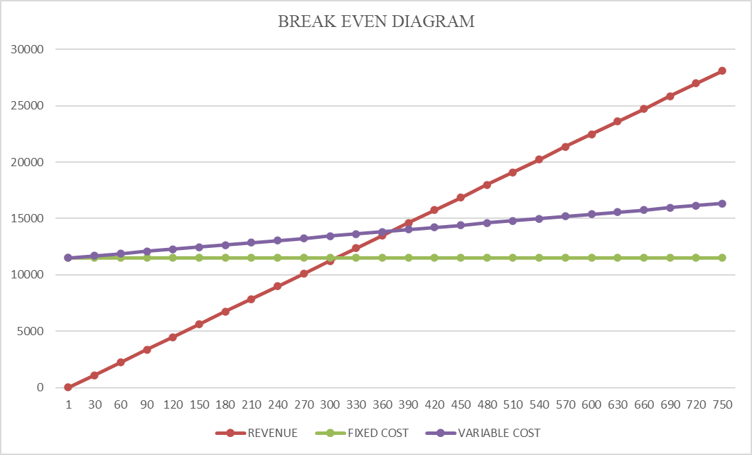

Figure 6. Break even diagram.

**Income Statement.** We will have in the first year a profit of 17.780 Euros with a margin of 10%, in the next years we will increase the sales and keep the cost of our business.

Table 9. Income Statement.

**Revenue 2026 % 2027 % 2028 % 2029 % 2030 %**

|  |  |  |  |  |  |  |  |  |  |  |
| --- | --- | --- | --- | --- | --- | --- | --- | --- | --- | --- |
| Freelancer Fremium  Freelancer Pro  Freelancer Elite  Client Subscription by job  Client Subscription Plans Pro  Client Subscription Plans Enterprise  Online Course Sales  Certification Couse Fees  Certification Couse Fees Premium | 6,000 | 3% | 9,000 | 3% | 10,800 | 3% | 14,040 | 3% | 21,060 | 3% |
| 8,380 | 5% | 15,084 | 5% | 18,101 | 5% | 23,531 | 5% | 35,297 | 5% |
| 18,180 | 10% | 32,724 | 10% | 39,269 | 10% | 51,049 | 10% | 76,574 | 10% |
| 60,000 | 32% | 90,000 | 28% | 108,000 | 28% | 140,400 | 28% | 210,600 | 28% |
| 8,450 | 5% | 12,675 | 4% | 15,210 | 4% | 19,773 | 4% | 29,660 | 4% |
| 4,120 | 2% | 6,180 | 2% | 7,416 | 2% | 9,641 | 2% | 14,461 | 2% |
| 13,080 | 7% | 52,320 | 16% | 62,784 | 16% | 81,619 | 16% | 122,429 | 16% |
| 30,390 | 16% | 45,585 | 14% | 54,702 | 14% | 71,113 | 14% | 106,669 | 14% |
| 36,240 | 20% | 54,360 | 17% | 65,232 | 17% | 84,802 | 17% | 127,202 | 17% |

**Total Revenues 184,840 317,928 381,514 495,968 743,952**

**Cost of services sold**

|  |  |  |  |  |  |  |  |  |  |  |
| --- | --- | --- | --- | --- | --- | --- | --- | --- | --- | --- |
| Web Hosting & Cloud Services  Marketing & Ads  Admin & Operations  Payment Processing Fees | 22,200 | 12% | 24,420 | 8% | 29,304 | 8% | 35,165 | 7% | 42,198 | 6% |
| 11,700 | 6% | 12,870 | 4% | 15,444 | 4% | 18,533 | 4% | 22,239 | 3% |
| 6,600 | 4% | 7,260 | 2% | 8,712 | 2% | 10,454 | 2% | 12,545 | 2% |
| 5,060 | 3% | 5,566 | 2% | 6,679 | 2% | 8,015 | 2% | 9,618 | 1% |

**Total Cost 45,560 25% 50,116 16% 60,139 16% 72,167 15% 86,600 12%** Gross Profit 139,280 75% 267,812 84% 321,374 84% 423,801 85% 657,351 88%

**Cost of Operations**

|  |  |  |  |  |  |  |  |  |  |  |  |  |  |  |  |  |
| --- | --- | --- | --- | --- | --- | --- | --- | --- | --- | --- | --- | --- | --- | --- | --- | --- |
| Full-Stack Developer  Course Content Manager  Customer Support (1 people)  Admin / Operations Officer  Office | | 49,500 | 27% | | 99,000 | 31% | | 108,900 | 29% | | 130,680 | 26% | | 156,816 | 21% | |
| 18,000 | 10% | | 36,000 | 11% | | 39,600 | 10% | | 47,520 | 10% | | 57,024 | 8% | |
| 15,000 | 8% | | 30,000 | 9% | | 33,000 | 9% | | 39,600 | 8% | | 47,520 | 6% | |
| 27,000 | 15% | | 54,000 | 17% | | 59,400 | 16% | | 71,280 | 14% | | 85,536 | 11% | |
| 12,000 | 6% | | 24,000 | 8% | | 26,400 | 7% | | 31,680 | 6% | | 38,016 | 5% | |
| **Total Expenses**  Net Profit | **121,500**  17,780 | | | **66**  **%**  **243,000**      10% 24,812 | | | **76% 267,300** 8% 54,074 | | | **70% 320,760** 14% 103,041 | | | **65% 384,912** 21% 272,439 | | | **52%**  37% |

***Balance Sheet*.** The owners’ equity will increase in the next years because we have more sales and the expenses will keep only in the second year we join to our business two full stack developers.

Table 10. Balance Sheet.

|  |  |  |  |  |  |  |
| --- | --- | --- | --- | --- | --- | --- |
| **Assets** |  |  | | | | |
| **Current assets:** |  | **2026** | **2027** | **2028** | **2029** | **2030** |
| Cash |  | 25,000.00 | 25,000.00 | 25,000.00 | 25,000.00 | 25,000.00 |
| Accounts receivable |  | 184,840.00 | 317,928.00 | 381,513.60 | 495,967.68 | 743,951.52 |
| **Total assets** |  | **209,840.00** | **342,928.00** | **406,513.60** | **520,967.68** | **768,951.52** |
| **Liabilities & owner's equity** |  |  |  |  |  |  |
| **Current liabilities:** |  | **2026** | **2027** | **2028** | **2029** | **2030** |
| Accounts payable |  | 57,560.00 | 74,116.00 | 86,539.20 | 103,847.04 | 124,616.45 |
| Payroll payabable |  | 109,500.00 | 219,000.00 | 240,900.00 | 289,080.00 | 346,896.00 |
| **Total current liabilities** |  | **167,060.00** | **293,116.00** | **327,439.20** | **392,927.04** | **471,512.45** |
| **Owner's equity:** |  | **2026 2027 2028 2029 2030** | | | | |
| Investment capital |  | 25,000.00 | 25,000.00 | 25,000.00 | 25,000.00 | 25,000.00 |
| Retain Earnings |  | 17,780.00 | 24,812.00 | 54,074.40 | 103,040.64 | 272,439.07 |
| **Total owner's equity** |  | **42,780.00** | **49,812.00** | **79,074.40** | **128,040.64** | **297,439.07** |
| **Total liabilities & owner's equity** |  | **209,840.00** | **342,928.00** | **406,513.60** | **520,967.68** | **768,951.52** |

###### 14. Risk Analysis

Table 10. Risk Analysis

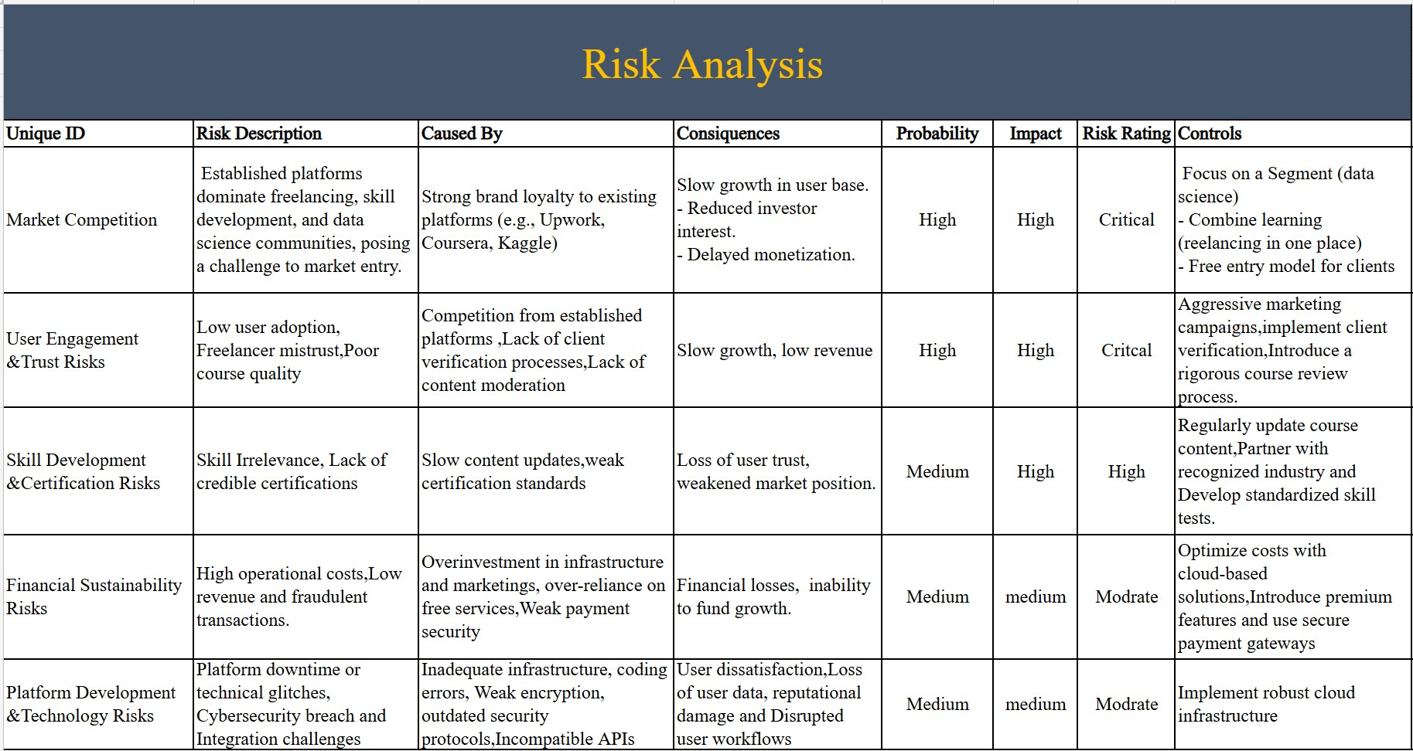

##### Conclusion

The initial inversion is around 20.000 Euros and we will have along the first period of analyze (first year) a positive cash flow. In this first year we will have a profit of 17.000 with a margin of 10%. This means our project is profitable and we will have in the initial year a good performance and this will help us to increase our sales in the next years implementing our strategy in this industry.

The business combines multiple revenue subscriptions, courses, and commission within an all-in-one experience. This creates clear differentiation and potential for sustainable, scalable growth as demand for data science talent accelerates.

Success will rely heavily on attracting and retaining high-quality freelancers and clients. Focus first on building a strong community with visible success stories, transparent

reviews, and clear certification standards to establish credibility.

##### References

BARNEY, J., 1991. Firm Resources and Sustained Competitive Advantage. *Journal of Management*, 17(1), pp. 99–120.

CASE, T., 2025. *Recent College Grads Are Not Ready for Work and HR Leaders Are Fed up*. [online]. WorkLife. Available from: [https://www.worklife.news/talent/recent-collegegrads-are-not-ready-for-work-and-hr-leaders-are-fed-up/.](https://www.worklife.news/talent/recent-college-grads-are-not-ready-for-work-and-hr-leaders-are-fed-up/)

CB INSIGHTS, 2021. *Why Startups Fail: Top 12 Reasons*. [online]. CB Insights Research.

Available from: [https://www.cbinsights.com/research/report/startup-failure-reasons-top/.](https://www.cbinsights.com/research/report/startup-failure-reasons-top/)

CHOWDHURY, T., 2023. *A Complete Guide to the Ideal Tech Startup Team Structure*. [online]. Technext Limited. Available from: [https://technext.it/tech-startup-teamstructure/.](https://technext.it/tech-startup-team-structure/)

CIPS, 2023. *Porter’s Five Forces Explained*. [online]. Cips.org. Available from: [https://www.cips.org/intelligence-hub/procurement/porters-five-forces.](https://www.cips.org/intelligence-hub/procurement/porters-five-forces)

COURSERA, 2025. *Coursera | Online Courses & Credentials by Top Educators. Join for Free*. [online]. Coursera. Available from: [https://www.coursera.org.](https://www.coursera.org/)

DATACAMP, INC, 2025. *Learn R, Python & Data Science Online*. [online]. [www.datacamp.com.](https://www.datacamp.com/) Available from: [https://www.datacamp.com.](https://www.datacamp.com/)

DELOITTE GLOBAL, 2020. *2020 Global Marketing Trends*. [online]. Deloitte. Available from: [https://www.deloitte.com/global/en/our-thinking/insights/topics/marketingsales/global-marketing-trends/2020.html.](https://www.deloitte.com/global/en/our-thinking/insights/topics/marketing-sales/global-marketing-trends/2020.html)

EDX LLC, 2024. *Schools and Partners*. [online]. EdX. Available from: [https://www.edx.org/schools-partners.](https://www.edx.org/schools-partners)

EUROPEAN PARLIAMENT, 2019. *Gig economy: How the EU Improves Platform Workers’ Rights*. [online]. Topics | European Parliament. Available from: [https://www.europarl.europa.eu/topics/en/article/20190404STO35070/gig-economy-howthe-eu-improves-platform-workers-rights.](https://www.europarl.europa.eu/topics/en/article/20190404STO35070/gig-economy-how-the-eu-improves-platform-workers-rights)

FIVERR INTERNATIONAL LTD, 2023. *Fiverr*. [online]. fiverr.com. Available from: [https://de.fiverr.com](https://de.fiverr.com/) [Accessed 20 Jun 2025].

FUNCTIONLY, 2025. *What You Need to Know about Building a Startup Org Structure*.

[online]. [www.functionly.com.](https://www.functionly.com/) Available from:

[https://www.functionly.com/orginometry/industry-org-charts/what-you-need-to-knowabout-building-a-startup-org-structure.](https://www.functionly.com/orginometry/industry-org-charts/what-you-need-to-know-about-building-a-startup-org-structure)

GOLDMAN SACHS, 2023. *AI Investment Forecast to Approach $200 Billion Globally by*

*2025*. [online]. [www.goldmansachs.com.](https://www.goldmansachs.com/) Available from:

[https://www.goldmansachs.com/insights/articles/ai-investment-forecast-to-approach-200billion-globally-by-2025.](https://www.goldmansachs.com/insights/articles/ai-investment-forecast-to-approach-200-billion-globally-by-2025)

GRATTON, P., 2025. *Porter’s Five Forces Explained and How to Use the Model*. [online]. Investopedia. Available from: [https://www.investopedia.com/terms/p/porter.asp.](https://www.investopedia.com/terms/p/porter.asp)

HARVARD BUSINESS SCHOOL, 1979. *The Five Forces*. [online]. Harvard Business School. Available from: [https://www.isc.hbs.edu/strategy/business-strategy/Pages/thefive-forces.aspx.](https://www.isc.hbs.edu/strategy/business-strategy/Pages/the-five-forces.aspx)

KAGGLE, 2025. *Kaggle: Your Home for Data Science*. [online]. Kaggle.com. Available from: [https://www.kaggle.com.](https://www.kaggle.com/)

KERR, B., 2024. *Understanding California’s Assembly Bill 5 (AB5): a Guide for Businesses Who Rely on Freelancers*. [online]. Worksome.com. Worksome. Available from: [https://www.worksome.com/blog/understanding-californias-assembly-bill-5-ab5-aguide-for-businesses-who-rely-on-freelancers.](https://www.worksome.com/blog/understanding-californias-assembly-bill-5-ab5-a-guide-for-businesses-who-rely-on-freelancers)

LINKEDIN, 2025. *LinkedIn*. [online]. Linkedin.com. LinkedIn. Available from: [https://www.linkedin.com/.](https://www.linkedin.com/)

LINKEDIN, 2017. *Marketing & Advertising on LinkedIn | LinkedIn Marketing Solutions*. [online]. Linkedin.com. Marketing & Advertising on LinkedIn | LinkedIn Marketing Solutions. Available from: [https://business.linkedin.com/marketing-solutions.](https://business.linkedin.com/marketing-solutions)

MCKINSEY, 2023. *Growth, Marketing & Sales Insights | McKinsey & Company*. [online]. [www.mckinsey.com.](https://www.mckinsey.com/) Available from: [https://www.mckinsey.com/capabilities/growthmarketing-and-sales/our-insights.](https://www.mckinsey.com/capabilities/growth-marketing-and-sales/our-insights)

MCLACHLAN, D., 2022. *How to Make a Risk Assessment Matrix in Excel*. [online]. [www.youtube.com.](https://www.youtube.com/) Available from: [https://www.youtube.com/watch?v=KIS4L4kn0RM.](https://www.youtube.com/watch?v=KIS4L4kn0RM)

MOTTOLA, M., 2025. *Why a 260% Jump in Freelance Hiring Signals Changing Times in*

*North America*. [online]. Entrepreneur. Available from:

[https://www.entrepreneur.com/leadership/why-the-260-jump-in-freelance-hiring-signalsa-major-shift/487146.](https://www.entrepreneur.com/leadership/why-the-260-jump-in-freelance-hiring-signals-a-major-shift/487146)

NAYELI JARAMILLO-PLATA, 2025. *Degree in hand, Jobs out of reach: Why Recent Grads Are Struggling in a Competitive Market*. [online]. CNN. Available from: <https://edition.cnn.com/2025/01/26/economy/job-market-recent-grads-colleges>[Accessed 20 Jun 2025].

NEILPATEL, 2019. *Digitales Marketing Leicht gemacht: Eine Schritt-für-SchrittAnleitung*. [online]. Neil Patel. Available from: [https://neilpatel.com/de/digitalesmarketing-leicht-gemacht-eine-schritt-fur-schritt-anleitung/](https://neilpatel.com/de/digitales-marketing-leicht-gemacht-eine-schritt-fur-schritt-anleitung/) [Accessed 25 Jun 2025].

NICHOLAS, J., 2022. *Introduction to VRIN Framework | VRIO Analysis | BusinessAnalystMentor.com*. [online]. businessanalystmentor.com. Available from:

[https://businessanalystmentor.com/vrin-framework-vrio-analysis/.](https://businessanalystmentor.com/vrin-framework-vrio-analysis/)

PEARSON, 2014. *Marketing Management*. [online]. [www.pearson.com.](https://www.pearson.com/) Available from:

[https://www.pearson.com/en-us/subject-catalog/p/marketingmanagement/P200000007478/9780133856460.](https://www.pearson.com/en-us/subject-catalog/p/marketing-management/P200000007478/9780133856460)

PEARSON, 2023. *Search*. [online]. Pearson.com. Available from: [https://www.pearson.com/en-gb/search.html?aq=digital%20marketing.](https://www.pearson.com/en-gb/search.html?aq=digital%20marketing)

PRECEDENCE RESEARCH, 2025. *Data Science Platform Market Size, Trends, Growth, Report 2030*. [online]. [www.precedenceresearch.com.](https://www.precedenceresearch.com/) Available from: [https://www.precedenceresearch.com/data-science-platforms-market.](https://www.precedenceresearch.com/data-science-platforms-market)

SMILES, A., 2020. *Everything Freelancers Need to Know about AB5 | Collective*. [online]. Collective. Available from: [https://www.collective.com/blog/everything-freelancers-needto-know-about-ab5](https://www.collective.com/blog/everything-freelancers-need-to-know-about-ab5) [Accessed 3 Jun 2025].

STATISTA, 2024. *Online Education - Worldwide | Statista Market Forecast*. [online]. Statista. Available from: [https://www.statista.com/outlook/emo/onlineeducation/worldwide.](https://www.statista.com/outlook/emo/online-education/worldwide)

STEVE BLANK, 2019. *Steve Blank Startup Tools*. [online]. Steve Blank . Steve Blank .

Available from: [https://steveblank.com/tools-and-blogs-for-entrepreneurs/.](https://steveblank.com/tools-and-blogs-for-entrepreneurs/)

THEORG, 2025. *Coursera - Org Chart, Teams, Culture & Jobs*. [online]. THE ORG.

Available from: [https://theorg.com/org/coursera.](https://theorg.com/org/coursera)

TOPTAL, 2025. *Toptal - Hire Freelance Talent from the Top 3%*. [online]. [www.toptal.com.](https://www.toptal.com/) Available from: [https://www.toptal.com/.](https://www.toptal.com/)

UDEMY, 2025. *Online Courses - Learn Anything, on Your Schedule | Udemy*. [online].

Udemy. Udemy. Available from: [https://www.udemy.com.](https://www.udemy.com/)

UPWORK, 2024. *Upwork | Hire Freelancers. Make Things happen.* [online]. Upwork.

Available from: [https://www.upwork.com.](https://www.upwork.com/)

VICENTE, V., 2024. *Risk Assessment Matrix: Overview and Guide*. [online]. Auditboard.com. Available from: [https://auditboard.com/blog/what-is-a-risk-assessmentmatrix.](https://auditboard.com/blog/what-is-a-risk-assessment-matrix)

WEBBER, J., 2025. *What Is the Average Online Course Completion Rate and Why Does It Matter?* [online]. LearnStream: Online Course and Membership Advice. Available from: [https://learnstream.io/blog/what-is-the-average-online-course-completion-rate-and-whydoes-it-matter/](https://learnstream.io/blog/what-is-the-average-online-course-completion-rate-and-why-does-it-matter/) [Accessed 20 Jun 2025].

WINTERS, J., 2018. *The Rise of Online Labour markets: Freelancing and Gig Working via Internet Platforms - IAB-Forum*. [online]. IAB-Forum. Available from: [https://iabforum.de/en/the-rise-of-online-labour-markets-freelancing-and-gig-working-via-internetplatforms/](https://iab-forum.de/en/the-rise-of-online-labour-markets-freelancing-and-gig-working-via-internet-platforms/) [Accessed 20 Jun 2025].

WORLD ECONOMIC FORUM, 2023. *The Future of Jobs Report 2023*. [online]. World Economic Forum. Available from: [https://www.weforum.org/publications/the-future-ofjobs-report-2023/.](https://www.weforum.org/publications/the-future-of-jobs-report-2023/)

##### List of Table

Table 1. VRIN Summary Table. ......................................................................................................................... 15

Table 2.Sales Strategy ............................................................................................................................................ 20

Table 3. Initial Inversion. ...................................................................................................................................... 23 Table 4. Sales by month. ....................................................................................................................................... 24 Table 5. Amount of customer. ............................................................................................................................. 24 Table 6. Disbursement. .......................................................................................................................................... 25

Table 7 Cash Flow .................................................................................................................................................. 25 Table 8. Income Statement. .................................................................................................................................. 26 Table 9. Balance Sheet. ......................................................................................................................................... 27

##### List of Figures

Figure 1. Logo. ............................................................................................................................................................ 4

Figure 2. 5 Forces Porter .......................................................................................................................................... 9 Figure 3. Identifying Competitive Advantages .............................................................................................. 17

Figure 4. Operational Plan .................................................................................................................................... 21

Figure 5. Organization. .......................................................................................................................................... 22 Figure 6. Break even diagram. ............................................................................................................................ 26

##### Appendices

**Appendix A**

